AnonyQuestionBox

Group members: Liu Yuchen, Zuo Yue, Zhang Di

1. **What is the problem:**

How to resolve the contradiction that young people desire to be understood but dare not show themselves in the society of acquaintances.

1. **How to solve:**

Build a social web application that focuses on anonymous questions. Users can put the link of the question box to their usual social platforms and invite others to ask questions.

Among the two parties in the interaction, only the identity of the questioner is hidden. After they ask a question, the person who initiated the question box needs to answer with their public accounts. The respondent is not anonymous, and his or her responses become part of his or her online self-presentation.

1. **Why it works:**

Anonymous question box may be one of the most concise ways of socializing in the mobile Internet era among Chinese teenagers. In addition to the function of releasing curiosity and frank communication, the anonymous question box also solves a major social confusion among young people social phobia because of its "safe distance" attribute.

The safe social distance constructed through the "anonymous" method has rekindled the desire of young people to communicate frankly. It is believed that the anonymous question box provides many people with the opportunity to "want to say something but can't say it". To some extent, it also increases the fun of interaction between friends and even strangers, which may become a new type of entertainment in the future.

1. **What is implementation (Function Modules):**

**4.1 Asking & Answer Module with Text Detection:**

The main feature of our website is an anonymous question box, where registered users can have their own question box, and other users can post questions anonymously into each other’s question box to start a chat.

The webpage of each question box owner only has his or her screen name and a text box. Visitors could put a question in it and wait for owner's reply. Only after the question has been answered will the question and answers be posted publicly on the owner’s webpage.

The answered chats are all publicly visible, but everyone except the mailbox host is anonymous.

Both the question text and the answer text will undergo text detection. If they contain sensitive words, they cannot be sent, so as to prevent the questioner and the questionee from being bullied by the Internet.

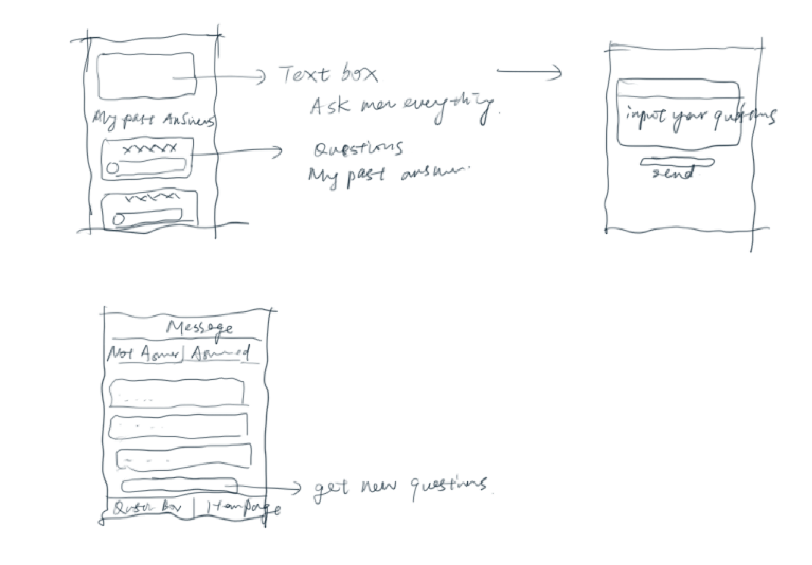

**4.2 Searching Questions & answers Module:**

The web page will provide a search box to search for uploaded questions or answers

**4.3 Automatic Text Reply:**

If you are asked questions related to basic information or schedule, you can automatically reply according to the information and will access the calendar api

**5 Directions to improve：**

Our website will provide this service and, if time permits, will add more features such as Facebook-like communities, etc.